III B. Tech I Semester Regular Examinations –November, 2025

introduction to artificial intelligence
(CSE)
Time: 150 Min Max. Marks:60M
SECTION – A
Answer all Four questions 4X8M=32M

1.
(a) | - In the context of a natural disaster management system, compare how a Simple Reflex Agent and a Goal-Based Agent would make decisions when responding to emergencies such as flood rescue operations. | [2M]
(b) | Imagine an AI Agent deployed to manage emergency supplies during a natural disaster. It must decide how to distribute limited food and medical kits across two affected zones:  Zone A: A densely populated urban area with high visibility and media coverage, but moderate damage.  Zone B: A remote village with severe damage and limited communication, but fewer people.  The AI Agent must allocate resources based on urgency, impact, and fairness.  How should the AI agent apply "intelligence" and "rationality" to make this decision? Should it prioritise Zone A for visibility and reach, or Zone B for severity and need? Discuss how the AI agent should apply ethical principles and rational reasoning methods to ensure balanced decision-making in this situation. | [3M]
(c) | Natural disaster: a flood has struck the region between Zone A and Zone B. You are the only trained rescuer with a small boat that can carry you plus one extra passenger or cargo item at a time. On the Zone A side are three urgent priorities that must be transported safely to Zone B: a child, a wolf, and a medical box, by keeping the following safety conditions in mind  - If the child is left alone with the rescue wolf without you present, the wolf may harm the child.  - If the child is left alone with the medicines without you present, the  child may accidentally consume the medication.  iii. You can row the boat alone or take exactly one of the three with you on each trip.  How would you algorithmically devise a solution to ensure the safe transport of the child, rescue dog, and medicines from Zone A to Zone B, adhering strictly to the above safety constraints? | [3M]
2.
(a) | - Compare informed and uninformed search strategies. In the context of search algorithms used in artificial intelligence, how do the fundamental differences between informed and uninformed search strategies impact their efficiency and effectiveness in solving complex problems within vast search spaces? | [2M]
(b) | Consider the following city map with cities Delhi, Nagpur, Jaipur, Agra, Gwalior, and Hyderabad, where each edge represents a possible path between the connected cities, start from City Delhi and the destination city Hyderabad.  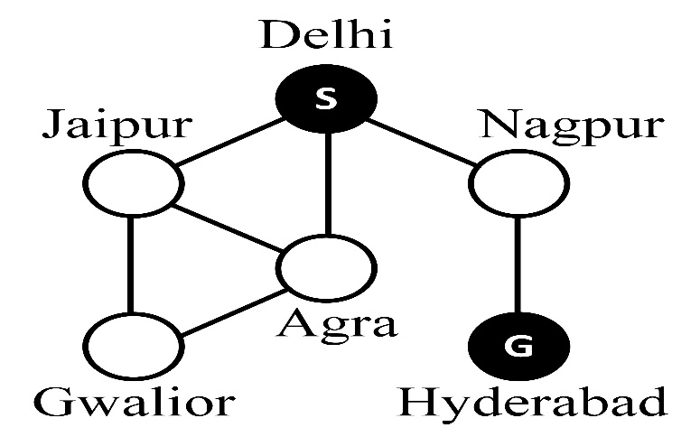  - Apply Breadth-First Search (BFS). Starting from the city of Delhi, expand the nearest unvisited city at each step and show the exact order in which the cities are explored. Clearly present the path obtained from Delhi to Hyderabad city.  - Apply Depth-First Search (DFS) to the given graph. Starting from the city of Delhi, explore the deepest unvisited city first. Write the exact order in which the cities are traversed, clearly indicate any backtracking steps that occur during the search process, and present the path obtained from Delhi to Hyderabad. | [4M]
(c) | Compare BFS and DFS in terms of completeness, optimality, and memory usage of the given city map. | [2M]
3.
(a) | Illustrate the importance of Propositional Logic in Knowledge Representation. Explain Resolution in Propositional Logic with one real-time example. | [2M]
(b) | Consider a vehicle that carries a spare tyre and needs to travel from a start location to a destination, crossing a desert area with no access to additional resources. The vehicle has a limited number of tyres (including the spare) and is at risk of tyre punctures along the way. Design a model for this problem in terms of planning for potential failures. | [3M]
(c) | Using resolution, determine the validity of the following argument:  - If the vehicle starts the journey, then it will enter the desert.  - If the vehicle enters the desert, then it will consume tyres.  - If the vehicle consumes tyres, then it will use the spare tyre.  - If the spare tyre is used, then the vehicle can reach the destination.  - The vehicle starts the journey.  - If the vehicle reaches the destination, then the mission will be successful.  Hence, prove: “The mission will be successful.” | [3M]
4.
(a) | Differentiate Classification and Clustering with real-time examples. | [2M]
(b) | Consider a company that provides a smart home energy monitoring system. The system collects data from various households, including daily electricity usage patterns, number of occupants, and time-of-day consumption peaks. The company wants to group households with similar energy usage behaviours to design customised energy-saving plans.  Illustrate how this problem fits into the concept of clustering, where the system must discover hidden patterns and form natural groupings among households without using predefined labels. Discuss what features could be used for clustering and how the resulting clusters could help in decision-making | [3M]
(c) | A company that provides smart home energy monitoring systems collects data from several households. Each household is characterised by two key attributes:  A: Average daily electricity consumption (in kWh)  B: Peak usage time indicator (numerical value representing time-of-day  pattern)  The company wants to group households with similar energy usage behaviours to design customised energy-saving plans for each segment.  You are given the following dataset of 10 households:  Household A (kWh/day) B (Peak Usage Pattern)  1 1.1 1.6  2 2.5 5.5  3 2.0 3.0  4 5.0 7.0  5 3.5 5.0  Apply the K-Means clustering algorithm to the given dataset. Take Households 2 and 5 as the initial cluster centres, and identify the new cluster centres after three iterations. Use Euclidean distance as the distance measure. | [3M]

SECTION - B
Answer all Two questions 2X14M=28M

5.
(a) | Differentiate Best-First Search (BFS) and A* Search in terms of their approach to finding a destination path. Describe how each algorithm evaluates nodes and chooses the next node to expand. | [3M]
(b) | 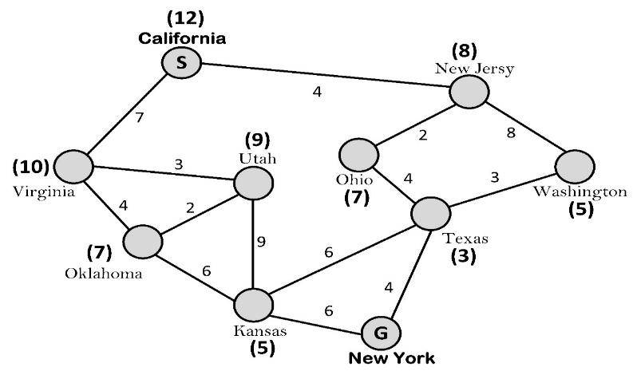  C Consider a world Map that represents a simplified version of Google Maps, where:  - Nodes represent cities,  - Edges represent road distances (in kilometres),  - The numbers in parentheses on each city represent the straight-line heuristic estimate (h) of the distance to the destination city, New York (G).  Your task is to help a route-planning AI system find a promising path from California (Start City S) to New York (Goal City G) using the Best-First Search algorithm and A* Algorithm.  Outline A* Algorithm. Illustrate how A* uses g(n) and h(n) to calculate f(n) and guide the search. Apply the algorithm step by step, showing the order of cities expansions, f(n) calculations, and path exploration. | [8M]
(c) | Identify the optimal path and its total cost from California to New York. Discuss why A* is more efficient than Best-First Search, in the above context, and justify. | [3M]
6.
(a) | - Summarize state-space search in the context of AI planning? Explain how state-space search  can be applied to the email classification scenario, such as Spam, Non-Spam, Primary, Social  and Promotions | [3M]
(b) | Consider the problem faced by an intelligent system that must plan and decide actions to achieve a desired goal, like how a spam detection system learns to distinguish between “spam” and “non-spam” emails based on labelled examples.  Explain how this problem can be modelled using both Forward and Backwards State Space Search approaches in planning, highlighting the role of the initial state, goal state, possible actions, transition model, and search strategy in efficiently exploring the state space to reach the desired goal. | [5M]
(c) | Consider the following dataset that classifies emails as spam or non-spam based on certain attributes' representation.  RID Links From Known Has Offer Words Is Reply Label  1 Yes No Yes No spam  2 No Yes No Yes non-spam  3 Yes No No No spam  4 No Yes No No non-spam  5 Yes No Yes Yes spam  6 No Yes No No non-spam  Implement a Decision Tree Classifier to predict whether an email is spam or non-spam using  ID3  - Compute the entropy of the dataset.  - Calculate the information gain for each attribute and identify the  best splitting the attribute at the root node.  - Construct the partial decision tree up to two levels based on  your calculations.  - Using the constructed tree, predict whether an email with the  following attributes would be spam or non-spam:  - Links: Yes,  - From Known: No,  - Has Offer Words: No,  - Is Reply: Yes  - Label:? | [6M]

